fWearables

Health technology

Fitness technology

* Body movement
* Activity levels
* Location
* Activity level = MET – metabolism time

Technology level

1. Programming – python
2. Data analysis – pre-processing, tokenization (labelling data to a specific name, like student id brings the full info on a student at a university),
3. Algorithm development – take consideration of everything

Where we are

1. Data collection:

* from our alpha prototype = electrodes, wet, sticks to the body. Collects and makes readings on info on heartrate, spo32, respiration, ppg, ambient and skin temperature and BIA and accelerometer. Stored in the form of excel sheet

1. Data processing

* Understanding the excel sheets
* Creating program to process the parameters – eliminate noise, clean the data and get the value

1. Patterns between each point: correlation between each point – develop program to understand patterns, e.g., what would happen to ppg if heart rate increase, ppg goes down and what happens to sp02 and spo2 fall to heart rate. This will help us to predict the hydration level so that the chips can start to work
2. Creating the algorithm

* Identifying the model
  + Understanding about the algorithms
  + Getting the right algorithms
* Training the model
  + Loading the data into the algorithms
  + Training the model - to identify pattern
* Checking the output
  + Giving values

1. Miniaturisation and sensor values direct collection

Fitness Technology

1. Body movement
2. Health technology
3. Fit ness technology

Body movement: body movement is considered to be any way you move your body, this includes exercise but also different physical patterns that you can do to move your body. Some types of body movements are:

1. Flexion and extension
2. Abduction and adduction
3. Circumduction
4. Elevation and deviation

Activity level: this is an expression of a person daily physical activity, usually measured or tracked with accelerometer, the amount of physical activity that a person does will affect how much water the body consumes to keep it running. Wearables technologies have activity trackers that can track the activity level of a person and uses an accelerator to translate body movement to data.

Location: fitness technology used location in order to track a person total distance walked and their level of physical activity, how fast they were going. It also reveals data on mileage, speed, location, and elevation and even track trajectory.

Competitor analysis

PyleUSA heart rate watches deploy a wireless ecg to monitor heart rate in the human body, however it is noted that wireless ecg can be inaccurate if there is sweat or moisture on the hand, and even inaccurate if the clear instruction is not followed.

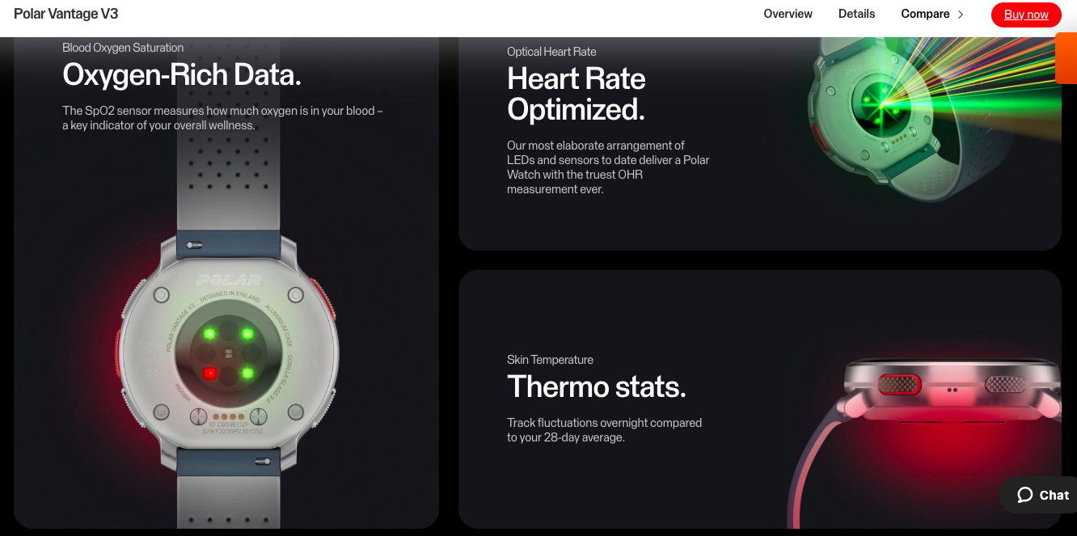

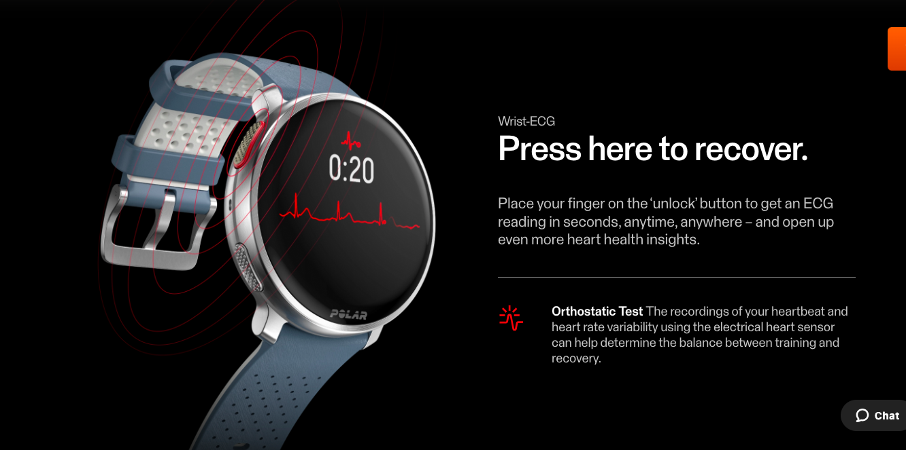

Ihealthlabs:

This proprietary blood pressure algorithm customizes to each user's unique physiology using regression modeling and neural networks, greatly improving the accuracy of systolic and diastolic blood pressure measurements.

Withings

**Electrocardiogram**

Detect atrial fibrillation

BPM Core records a medical-grade ECG thanks to 3 electrodes: 2 in the cuff and another in the steel tube held during the measurement. The data is shown live on the device and sent to the app, so you’ll see instant feedback if you show signs of atrial fibrillation.

Garmin

PULSE OX

All the various cells in your body need oxygen to function properly. Your circulatory system, which includes your heart, lungs and blood, all work together to import oxygen from the environment into your cells.

Oxygen is extracted from the air that fills your lungs when you inhale. It is mixed into your blood supply and pushed throughout your body with each heartbeat. A pulse oximeter measures how much oxygen (compared to maximum capacity) is in your bloodstream as it travels around your body.

If you think about your blood as a train and oxygen as the passengers on that train, a pulse oximeter is telling you how crowded the train is compared to maximum capacity. When every seat in the train has a passenger sitting in it, then the train is operating at 100% capacity.

Compatible Garmin wearables use a combination of red and infrared lights with sensors on the back of the device, which can estimate the percentage of oxygenated blood (peripheral oxygen saturation, SpO2%) available in your blood. Generally speaking, this value should be 95% or higher in most settings, but this value can be influenced by altitude, activity and an individual’s health. Numbers below 90% may be considered low, according to the [Mayo Clinic.](https://www.mayoclinic.org/)

Your device is not intended for medical purposes, and any questions about your Pulse Ox reading should be answered by your physician or other qualified health care professional. Pulse Ox not available on Garmin devices in all countries.

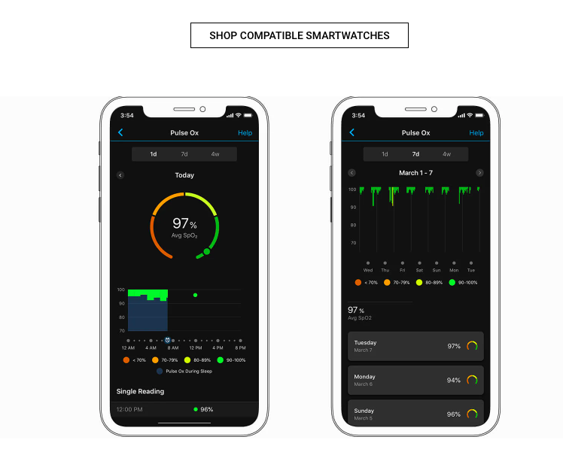

MET CHART

